AFYON KOCATEPE UNIVERSITY
FACULTY OF TECHNOLOGY
DEPARTMENT OF AUTOMOTIVE ENGINEERING

THE EFFECT OF MATERIAL PARAMETERS USED IN
VEHICLE FILTER MANUFACTURING ON FILTRATION

174205024 - Kağan BAĞDEMİR
UNDERGRADUATE GRADUATION THESIS
Supervisor: Prof. Dr. Fatih AKSOY
Afyon, 2022

Title Page

THE EFFECT OF MATERIAL PARAMETERS USED IN VEHICLE
FILTER MANUFACTURING ON FILTRATION

Kağan Bağdemir
Afyon Kocatepe University
Faculty of Technology
Department of Automotive Engineering
Supervisor: Assoc. Prof. Dr. Fatih AKSOY

Abstract
This study examines the general structure of filters used in filtration processes, their functions, and the effect of the materials used in them on filtration performance.
Vehicles need filters in order to protect their operating systems. Since filters directly affect vehicle performance, their importance is very high. For this reason, the quality of the materials used in the production of a vehicle filter can influence filtration efficiency either positively or negatively. Filters can be manufactured from many materials; however, they basically consist of main components such as paper, cover, and gasket. The material parameters of these main components directly affect the function of the filter.
Different parameters are important for each material. For papers, parameters such as air permeability, burst pressure, and pore size are important, whereas for covers, the components of the material and the material mixtures used are of primary importance.
2022, xiii + 60 pages Keywords: Filter, Filtration, Material, Permeability, Pressure, Pore

Scientific Ethics Declaration
At Afyon Kocatepe University, Faculty of Technology, in this thesis prepared in accordance with the thesis writing rules, I declare that:
all information and documents in the thesis were obtained within the framework of academic rules,
all visual, auditory, and written information and results were presented in accordance with scientific ethics,
when I benefited from the works of others, I cited the relevant works in accordance with scientific norms,
all the works I cited were included in the references,
no falsification was made in the data used,
and no part of this thesis was submitted as another thesis study at this university or any other university.
Date: 14 / 05 / 2022 Signature: Kağan BAĞDEMİR

Acknowledgements
I would like to thank my thesis advisor, Prof. Dr. Fatih AKSOY, for his major contributions to the determination of the topic of this research, the guidance of the experimental studies, the evaluation of the results, and the writing process. I also thank my instructors and friends, who supported me throughout the research and writing stages with their suggestions, criticism, and assistance.
I would also like to thank my family for their financial and moral support throughout this study.
Kağan BAĞDEMİR Afyonkarahisar, 2022

Table of Contents
1. Introduction 1.1 Life Cycle of Filters 1.2 Filter Production in Turkey and in the World 1.2.1 Filter Production in the World 1.2.2 Filter Production in Turkey 2. Types of Filters and the Materials Used in Filters 2.1 What Is a Filter? 2.1.2 Air Filters 2.1.3 Panel Air Filters 2.1.3.1 Materials Used in Panel Air Filters 2.1.3.2 Filter Paper Parameters Used in Panel Air Filters 2.1.2 Radial Air Filters 2.1.2.1 Materials Used in Radial Air Filters 2.1.2.2 Filter Paper Parameters Used in Radial Air Filters 2.1.3 Powercore Air Filters 2.1.3.1 Materials Used in Powercore Air Filters 2.1.3.2 Filter Paper Parameters Used in Powercore Air Filters 2.2 Cabin (Pollen) Filters 2.2.1 Plain Pollen Filters 2.2.2 Carbon Pollen Filters 2.2.2.1 Materials Used in Pollen and Carbon Pollen Filters 2.2.2.2 Filter Paper Parameters Used in Pollen and Carbon Pollen Filters 2.3 Oil Filters 2.3.1 Full-Flow (Primary) Oil Filters 2.3.2 Secondary Oil Filters 2.3.3 Ecological Oil Filters 2.3.4 Spin-on Oil Filters 2.3.5 Spinner Oil Filters 2.3.6 Magnetic Oil Filters 2.3.1.1 Materials Used in Oil Filters 2.3.1.2 Filter Paper Parameters Used in Oil Filters 2.4 Fuel Filters 2.4.1 Diesel-Type Fuel Filters 2.4.2 Gasoline Fuel Filters 2.4.3 Ecological Fuel Filters 2.4.4 Spin-on Fuel Filters 2.4.1 Materials Used in Fuel Filters 2.4.2 Filter Paper Parameters Used in Fuel Filters 3. Material and Method 3.1 Measuring Instruments 3.1.1 Caliper 3.1.2 Precision Scale 3.1.3 Radius Gauge 3.1.4 Shore Meter 3.1.5 Micrometer 3.2 Machines Used for Paper Testing 4. Experiment 5. Conclusion References

List of Symbols and Abbreviations
ELY - Fiber
EVA - Ethylene Vinyl Acetate
GF - Glass Fiber
NBR - Nitrile
PA6 - Polyamide 6
PP - Polypropylene

List of Figures
1. Example of the filtration process 2. Installation of a new panel filter in a vehicle 3. Filter market value in North America 4. Used and dirty panel air filter 5. Filter types 6. Example of a panel air filter 7. The section where the panel air filter must be installed in the vehicle 8. Expanded salmon-colored polyurethane 9. Pouring polyurethane into the mold with machine assistance 10. Four-strip hot-melt used in panel filters 11. Panel air filter paper 12. The section where the polyurethane radial air filter must be installed in the vehicle 13. Radial air filter with sheet-metal cover 14. String-wrapping technology in radial filters 15. Flat perforated sheet-metal casing used in radial filters 16. Polyurethane poured into a radial mold 17. Example of a felt inner filter 18. Structure of the filter paper used in a Powercore air filter 19. Powercore air filter together with its housing 20. Powercore air filter as a kit 21. Powercore centering element 22. Pollen filter 23. Dirty and clean pollen filters 24. Layers of a carbon pollen filter 25. Carbon pollen filter 26. Pollen filter felt 27. Carbon pollen filter paper 28. Oil filter replacement 29. Types of oil filters 30. Schematic of a full-flow oil filter 31. Ecological oil filter and gasket set 32. Spin-on type oil filter 33. Oil flow in a spin-on type oil filter 34. Spinner-type oil filter 35. Magnetic oil filter 36. Examples of oil filter paper 37. Fuel filters 38. Diesel fuel filter 39. Gasoline fuel filter 40. Example of a spin-on fuel filter 41. Examples of O-ring type element filter gaskets 42. Example of green fuel filter paper 43. Mechanical caliper 44. Precision scale 45. Radius gauge 46. Shore meter 47. Micrometer 48. Filter paper thickness graph by product type 49. Placement of a filter paper sample into the test device 50. Filter paper test device display 51. Comparison of air permeability of filter papers by product type 52. Burst pressure measurement 53. Cutting the paper for the chamber of the measuring device 54. Air permeability display that should be reset because previous values remain 55. Adjustment of the air flow valve 56. Reading the air permeability value from the display 57. Pouring alcohol onto the paper for the pore permeability test 58. Opening the pressure regulator 59. Measurement of maximum pore size 60. Average pore size 61. Oil filter paper placed in the burst pressure machine 62. Burst pressure measurement display 63. Reading the burst pressure from the screen

List of Tables
1. Filter types and recommended replacement intervals 2. Recommended parameters for panel filter paper 3. Example parameters for Powercore filter paper 4. Example parameters for pollen filter paper 5. Example parameters for carbon pollen filter paper 6. Example parameters for oil filter paper 7. Example parameters for melt-blown filter paper

1. Introduction
Vehicles are always exposed to dirt depending on where they are used. Since vehicles are mostly operated on roads, they require units that must be taken from outside, such as air, oil, and fuel, for the parts necessary for their operation. However, because these externally supplied units are exposed to contaminants, they can reach a condition that may damage the vehicle. In order to prevent this, filters are needed. In the simplest sense, a filter is a component used to prevent a harmful substance from passing into an area where it is not desired.
There are many classes of filters used in vehicles, and filtration is carried out according to these classes. In each different filter type, different materials are preferred depending on where the filter is used, and the parameters of these materials may vary according to several conditions. If an incorrect filter produced from materials with incorrect parameters is installed in the vehicle, performance decreases and the vehicle becomes inefficient.
This thesis examines how and to what extent the materials used in filters affect the filtration process and how the parameters of these materials can be measured.

1.1 Life Cycle of Filters
At first glance, the operating principle of filters seems very simple. However, when examined in detail, it becomes clear that filters perform many functions and are highly important.
In general, the life cycle of filters can be explained in five stages:
1. The materials that need to be filtered approach the filter surface. 2. The filter paper traps and retains dust, residue, sand, insects, dirt, and similar substances. 3. As materials pass through the filter, pollutants accumulate continuously. 4. Over time, the accumulated contaminants clog the filter and reduce the flow. 5. Because of clogging, the service life of the filter ends and it must be replaced. When a new filter is installed, the cycle is completed.
This general operating logic is valid for almost every filter type. The basic principle of a filter is to prevent incoming contaminants from reaching the vehicle or the system to which the filter is connected. In this respect, the quality of the materials used in filters and the parameters of those materials are vital.
Table 1. Filter types and recommended replacement intervals
Filter Type | Recommended mileage / interval
Fuel filters | Every 40,000 km or every 4 years
Oil filters | Every 5,000 km
Air filters | Every 39,000 km
Pollen filters | Between 10,000 and 20,000 km

1.2 Filter Production in Turkey and in the World

1.2.1 Filter Production in the World
The global filter industry has a significant share and continues to grow together with the automotive sector. Even if the production of fossil-fuel-powered vehicles decreases, the need for certain filter types will continue; therefore, the vehicle filter sector is considered a long-lasting sector.
Five brands stand out in terms of quality in filter production: Mann Filter, Bosch, Donaldson, Sogefi, and Mahle. Increasing environmental regulations and environmentally friendly approaches around the world further increase the need for filters. For this reason, qualified and environmentally friendly filter production is becoming increasingly important on a global scale.
As vehicle production increases and new vehicles appear worldwide, filter production will continue to grow even if filter types change.

1.2.2 Filter Production in Turkey
The filter industry in Turkey also has a considerable share. The first filter factory in the country, Fil Filter, was established in İskenderun in 1966. With the establishment of additional filter factories, İskenderun became one of the most dominant regions in Turkey's filter industry. Well-known brands such as Fil Filter and Asaş Filter are manufactured in İskenderun. According to export data, approximately 65% of Turkey's filter production is carried out in Hatay Province. Turkey is striving to reach OEM quality standards in filter production, and the company considered closest to this level is Fil Filter, the country's first filter manufacturer.
Filter production facilities developed in İskenderun have also started exporting filters abroad. Thanks to this, Turkey has risen to the position of one of the important filter producers worldwide. Through domestic R&D activities, new filters are designed and manufactured, and this has accelerated the growth of the filter sector in Turkey.
Many types of filters are produced in Turkey, including oil, fuel, air, cabin, hydraulic, and dryer filters. Auxiliary products such as casings and covers required for the production of these filters are also manufactured domestically. According to the Turkish Statistical Institute, Turkey's annual filter demand is around 165 million units, which further increases the need for production. In order to produce in accordance with ISO and IATF standards, companies in Turkey receive training and continually improve themselves. Demand from the American, Asian, and European markets is high, and some Turkish filter brands have even reached the level of establishing warehouses abroad.

2. Types of Filters and the Materials Used in Filters

2.1 What Is a Filter?
In general, filters are components used in vehicles to prevent harmful substances from reaching the system. The absence of a filter in a vehicle causes a shorter service life, a decrease in performance, and the inability of the vehicle to use its full potential. The word *filter* derives from the French term meaning “felt used as a strainer,” and earlier from the Germanic verb *feltjan*. In vehicles, filters protect the vehicle by carrying out the filtration process in accordance with the meaning of the word.
Just as people need food and water to survive, vehicles need externally supplied air, oil, and fuel that must be filtered for healthy operation. Filters are necessary so that the externally supplied substances can be used safely. Thanks to filters, the mechanisms in which they are used are affected by external factors only minimally.
In summary, filters are used to prevent particles such as dust, residue, sand, and insects from reaching the operating mechanism and reducing performance.
The main filter groups can be listed as follows:
Air filters
Oil filters
Fuel filters
Cabin (pollen) filters
Besides these, there are other filter types as well. However, these four are among the best known and most important. Depending on their shape and the vehicles to which they are fitted, they may be called by different names. Since both the installation location and the required performance characteristics vary, the materials used in them may also vary accordingly.

2.1.2 Air Filters
Air filters are the parts that clean the air required for the operation of the vehicle while it is going to the engine, thereby protecting the engine from damage. They retain particles such as dust, residue, sand, insects, dirt, and other contaminants found in incoming air.
Air filters are used in many fields besides vehicles, and this wide range of application increases their popularity. The air filters most commonly used in vehicles can be divided into three groups according to their shape and area of use:
Panel air filters
Radial air filters
Powercore air filters

2.1.3 Panel Air Filters
Like other air filters, panel filters are used to clean the air used in the engine. They are generally rectangular in shape. Their width and length are typically around 200 mm, while their height is around 50 mm, although these dimensions vary according to the installation area in the vehicle.
Most panel filters are produced using three basic materials: polyurethane, hot-melt, and filter paper. There are also panel filters in which the outer part is surrounded by a metal or plastic casing, as well as rarer models using sponge, fiber, or felt.
The hot-melt used in panel air filters can be applied in multiple strips in proportion to the length of the filter. Although panel filters are generally rectangular because of the vehicle installation area, exceptions such as pentagonal, trapezoidal, or triangular shapes also exist. In non-linear geometries, edge hot-melts are applied according to the angles of the polygon to hold the polyurethane and ensure bonding between the polyurethane and the paper.
Unlike many other filter types, panel air filters generally do not contain separate gaskets and therefore can be installed as simple, monolithic parts. They are among the easiest filter types to install. When the hood is opened, the housing of the panel filter is opened, the old filter is removed, and the new one is placed in position. To ensure balanced and clean airflow to the engine, they must be replaced when their service interval arrives.

2.1.3.1 Materials Used in Panel Air Filters
Panel air filters mainly use filter paper, hot-melt, and polyurethane. Other materials used less frequently include felt, sheet-metal casing, and sponge. The polyurethane used in panel air filters serves functions such as sealing and centering in the vehicle. In air filters, salmon-colored polyurethane is used most frequently, and the average hardness is generally around 28 ± 5 Shore. These values are influenced by environmental humidity and temperature. Depending on seasonal conditions, polyurethane is typically processed at around 24 ± 3 °C, with humidity in the range of 35-45%. Typical values include a curing time of 24 hours, a hardening time of 7 minutes, a mold temperature of 35-40 °C, and a tank/storage temperature of around 24 ± 3 °C.
For panel air filters, the density of polyurethane generally varies between 250 and 350, depending on the product. Density is a very important parameter for the sealing function of polyurethane. If the material is too low or too high in density, it may not withstand environmental conditions during operation and may fail to perform its function. In such cases the filter must be replaced, so the density value of the polyurethane directly affects service life.
Polyurethane is known for being easy to shape. It is an organic material and resistant to burning, which makes it useful in many fields. Because it is also a highly durable polymer, it is widely used in filters.
Polyol is used in polyurethane production and is mixed with isocyanate. During the mixing process, the machine must operate continuously; if the machine stops, the mixture freezes and loses its function. The raw material of isocyanate is petroleum, and it plays an important role in the solidification of the polyurethane mixture. Once the mixtures in the first and second tanks are ready, they are mixed to obtain polyurethane. The polyurethane is stored in barrels and later poured evenly into the mold during panel filter production.
The proportion of isocyanate in the polyurethane mixture directly affects the softness and Shore hardness of the polyurethane. For this reason, pouring at fixed parameters is very important.
Hot-melt acts as the bonding component between the polyurethane and the paper in panel air filters. Hot-melts are also known as hot adhesives. There are two common types: glass hot-melt and normal hot-melt. Panel air filters generally use normal hot-melt, while glass hot-melts are more common in element-type filters such as fuel and oil filters. Because glass hot-melts break easily, they are given this name. Depending on the required strength of the filter, normal hot-melts may be applied in double rows or four rows. In some filters, this may increase up to eight strips arranged both above and below. Hot-melt can be applied to the filter paper either before or after assembly, but pre-application is considered more advantageous in terms of strength.
Hot-melt formulations contain polymers, resins, antioxidants, and plasticizers. By changing the proportions of these chemicals, properties such as fluidity and adhesion can be adjusted. EVA can be given as an example of a polymer used in hot-melt. Polymers directly affect flexibility, resins provide adhesion, antioxidants prevent degradation and extend service life, and plasticizers also contribute to flexibility.
In hot-melt production, viscosity is a critical parameter. If the viscosity is low when a problem occurs, it can be adjusted with heat; however, if the viscosity is too high, this intervention is not possible. For this reason, a lower viscosity within tolerance is considered advantageous. Depending on additives, hot-melts can appear in different colors, but in finished products they are usually seen in an adhesive-like color.

2.1.3.2 Filter Paper Parameters Used in Panel Air Filters
Air filter paper is the section that performs the actual filtration. In panel air filters, papers with an air permeability of 270-300 L/m²s are commonly used. Although these values vary from vehicle to vehicle, values outside this range may cause either too little or too much air to reach the engine; therefore, such abnormal values are not preferred. These values are tied to standards, although the related codes may differ between companies.
A typical set of average parameters for panel air filter paper is given below.
Table 2. Recommended parameters for panel filter paper
Parameter | Example Average Value
Thickness | 0.5 mm
Air permeability | 270-300 L/m²s
Burst pressure | > 200 kPa
Maximum pore size | < 50 µm
Grammage | 120 g

Since these filters supply air directly to the engine, these values directly affect filtration performance. Pore size affects how much air passes through the paper and therefore affects the air available for combustion. Because the filter paper influences engine operation directly, the parameters used in its production must be suitable for healthy airflow in that specific vehicle.
Grammage values are measured by cutting the paper into a standard square sample and weighing it with a precision balance. In pore-size testing, the machine displays two values: maximum and average. Maximum pore size is the value read when the first bubble is observed after ethyl alcohol is poured and the air pressure is applied.

2.1.2 Radial Air Filters
Unlike panel air filters, radial air filters have a radial shape and are heavier. Like panel air filters, they are used to prevent harmful particles from reaching the engine. Radial air filters are mostly used in heavy vehicles. Therefore, the selection of a radial air filter is made according to the installation area on the vehicle. They can also be sold as a kit with inner and outer filters. The inner filter is usually produced to support the main outer filter and is designed to fit inside it with suitable outer diameter and height.
Radial air filters can be divided into two groups according to the cover material:
Polyurethane air filters
Sheet-metal-cover air filters
Polyurethane radial air filters are generally produced using air filter paper, lower and upper polyurethane, outer casing, and inner casing. In sheet-metal-cover radial filters, metal covers are used instead of polyurethane covers. One of the most important differences between these types is that sheet-metal-cover filters contain the seating hole that fits the vehicle. These hole diameters are critical. A filter produced with the wrong diameter is difficult to correct.
In radial air filters, inner and outer wire casings are used to provide strength. The shape and thickness of the wire casing affect durability and allow the filter to operate for long periods, especially in heavy vehicles. In situations where wires are insufficient, or depending on the temperature conditions of the operating environment, string-wrapping technology may also be used.

2.1.2.1 Materials Used in Radial Air Filters
Like panel air filters, radial air filters use main materials such as paper and polyurethane. In the sheet-metal-cover versions, the end covers are made of metal. Because of the radial shape, wire casings or string-wrapping technology are used to provide mechanical strength. The wires and the paper are assembled with polyurethane poured into molds to form the filter. This must be done quickly before the polyurethane solidifies. Therefore, the solidification time of polyurethane must be appropriate, which in turn requires correct pouring conditions.
The casings used in radial air filters have many forms in terms of both cost and function. Examples include:
Flat perforated
Helix perforated
Holed perforated
Tube helix
During production, the raw material in sheet form is placed in machines, perforated and shaped, and finally formed into the radial geometry and joined for use. Flat perforated and helix perforated casings are common in air filters, whereas holed perforated and tube helix casings are more common in element-type filters such as oil and fuel filters. This is directly related to strength and permeability.
For polyurethane used in radial air filters, suitable winter values are generally a density in the 300-400 range, a temperature of 13-20 °C, and a hardness of 15-25 Shore. These values vary according to product type and application area.
During the assembly of radial filter paper, if a polyurethane limiter is present, the paper is positioned according to it and the final length is calculated. The limiters in polyurethane molds define where the paper and wire should sit. During final length calculation, the expansion tolerance of polyurethane must also be taken into account. Depending on the mixture used, the material may not expand at all or may expand by about 0.5-1 mm.

2.1.2.2 Filter Paper Parameters Used in Radial Air Filters
The filter paper parameters of radial air filters are approximately similar to those of panel air filters because both are air filters. The main difference appears in the filtration area. Since radial air filters usually have a larger filtering surface, they often have a higher effective filtration area.
The filtration area can be calculated by multiplying the number of pleats, pleat depth, and pleat length, and then dividing by 50. This value indicates how much of the paper area participates in the filtration process.
In inner-outer filter kits, the material parameters of the paper may vary. In the inner filter, permeability may be higher or lower depending on whether it is intended to retain larger particles. In such inner filters, felt may be preferred instead of paper. The felt in the inner filter can be joined ultrasonically to the wire or directly to a plastic mesh. Inner and outer filters are generally produced simultaneously so that problems do not arise during testing.

2.1.3 Powercore Air Filters
Powercore filters are a type of filter known for their high efficiency. Heavy-duty vehicles and large vehicles with high horsepower generate high engine temperatures and therefore require more effective air filtration. Large vehicles also face space limitations, so the air filter used must be suitable for these conditions. To meet these needs, Donaldson developed Powercore air filter technology.
Powercore filters are a more innovative technology than many conventional filters. Their main goal is to perform the filtration process with maximum efficiency while occupying less space. Their compactness and high efficiency demonstrate the practical strength of Powercore technology.
The components of Powercore air filters include Powercore filter paper, a plastic centering element or casing, and, when necessary, a polyurethane seal.
The paper structure in Powercore filters is highly specialized. While air passes through the paper at different angles, the structure is designed not to allow dust and dirt to pass through. Because of this structure, it is also referred to as pyramid-shaped paper.
One of the most important features of Powercore filters is their resistance to burning and their ability to discharge up to 80% of dust to the outside through turbulence in the housing. In simpler terms, the housing benefits from a centrifugal effect that helps evacuate dirt outward.
In Powercore filters, the paper can be thought of as a dual-channel structure. One channel allows air to pass, whereas the other channel is closed at the end. In this way, dirt is retained while airflow is redirected toward the channel through which clean air can pass. Since air entering the closed channel cannot pass through it, it leaves its contaminants behind and is redirected through the open channel. Thanks to this special structure, maximum efficiency and maximum performance are targeted.
Powercore filters can retain approximately twice as much dirt and dust as competing filter technologies. Thanks to Powercore technology, performance problems in heavy vehicles are reduced and more effective filtration leads to better vehicle performance.

2.1.3.1 Materials Used in Powercore Air Filters
Powercore filters use plastic centering elements and Powercore filter paper. Depending on the application, there are also versions that use seals and polyurethane. The centering elements are generally made of PP (polypropylene). This provides an advantage under the dusty conditions in which vehicles using Powercore filters often operate. In other words, the centering element serves as a skeleton. In models with polyurethane it remains at the bottom, while in models without polyurethane it is located at the top, thereby helping the filter paper remain mechanically stable.
Products such as plastic centering elements and ecological covers are produced by injection molding after the material composition is adjusted. Each material has its own shrinkage ratio, and the mold is designed accordingly. In general, shrinkage values such as 16 per thousand or 9 per thousand are observed, but these values vary depending on the additives used.

2.1.3.2 Filter Paper Parameters Used in Powercore Air Filters
Powercore air filter paper has a highly special shape. However, if it is examined before being formed into that final shape, average values can still be determined and useful information about the paper can be obtained. Since Powercore filters operate under more difficult conditions than many other air filters, their paper parameters are also different.
Table 3. Example parameters for Powercore filter paper
Parameter | Example Average Value
Thickness | 0.4 mm
Air permeability | 150-240 L/m²s
Burst pressure | > 240 kPa
Maximum pore size | < 35 µm
Grammage | 90 g

Compared with other papers, untreated Powercore paper is thinner and has a smaller pore size. Powercore papers also stand out because of their flame-retardant structure. One surface is corrugated and the other is flat, and these layers are joined with hot-melt. The final form is obtained through Powercore paper winding technology, after which the paper is assembled with the other components and marketed either as a kit or as a single product.

2.2 Cabin (Pollen) Filters
Pollen filters can be examined under two main headings:
Plain pollen filters
Carbon pollen filters

2.2.1 Plain Pollen Filters
Plain pollen filters are among the least expensive and easiest filter types to produce. Their purpose is to ensure that the air entering the cabin of the vehicle is clean. For this reason, they contain filter paper and felt. As in other filter types, the paper prevents dirt, dust, insects, and similar undesired contaminants from entering the vehicle and sends cleaned air into the cabin, thereby improving the cleanliness and healthiness of the cabin air.
Pollen filters are among the lightest filter types. In some cases, installation can be difficult because of the stiffness of the felt. For this reason, elastic pollen filters produced with softer felt materials have also been developed.
Pollen filters are usually installed near the glovebox area of the vehicle, although there are exceptions. They also protect the air-conditioning system and extend its service life. Because they provide clean air, they may increase the driver's concentration time and help prevent headaches. Unlike some other filters, pollen filters do not directly affect vehicle performance, so drivers may underestimate their importance. However, using a dirty pollen filter can harm both the vehicle and the driver.
In general, pollen filters provide comfort to the driver, and regular replacement is important for the driving experience. Not every pollen filter should be fitted to every vehicle. If better filtration is desired, papers with smaller pore sizes should be preferred.

2.2.2 Carbon Pollen Filters
Unlike plain pollen filters, carbon pollen filters contain carbon in the filter paper section. The amount of carbon can vary, and as the amount of carbon used in the paper increases, the effectiveness of the filter also increases. Filters with higher carbon content filter odors better, thereby increasing driving comfort and making the cabin smell more stable.
One of the most obvious physical properties of carbon-containing filter papers is that they are much heavier than pollen filter papers without carbon. The paper in carbon cabin filters consists of three layers: first the particle filter layer, then the activated carbon layer, and finally the reinforcement layer. As the amount of carbon increases, the grammage of the paper and the overall product weight increase as well.
To facilitate installation, flexible elastic felts can be used in carbon pollen filters, just as in some plain pollen filters. In addition, versions with plastic frames, sponge, or tabs also exist. These materials either make installation easier or act as centering elements.

2.2.2.1 Materials Used in Pollen and Carbon Pollen Filters
Pollen filters basically use felt and paper, so they are less complicated than many other filter types. According to the felt used, they can be classified as normal-felt pollen filters and elastic pollen filters.
Plain felt is generally used in vehicles in which the filter can be installed without bending. The side felts used in pollen filters are usually 1 mm thick, although in some cases they can reach 2 mm. They are cut according to the width and length of the filter and glued to the sides. Depending on the vehicle, pollen filters may be produced with plastic centering elements or as dual kit sets. In double-filter sets, the two filters do not necessarily have the same dimensions; two-piece pollen filters of different sizes also exist.
The side felts are formed when standard felt raw material passes through a machine that applies a thermal process. Elastic side felts have a cotton-like structure, are softer, and can be bent more easily for installation. Their bulkier form results from being subjected to less processing. The same general situation applies to carbon pollen filters; the main difference is the type of paper used.

2.2.2.2 Filter Paper Parameters Used in Pollen and Carbon Pollen Filters
The most striking material difference between pollen filter paper and carbon pollen filter paper is thickness. The paper used in carbon pollen filters is approximately three times thicker. Carbon pollen filter paper is formed by combining three layers through heat treatment, including a carbon layer and felt layers.
For carbon pollen filters, the permeability factor is around 1000 L/m²/s, whereas for plain pollen filters it is around 3000 L/m²s. If the permeability value is too far from these ranges, the air entering the vehicle may be affected and this may have negative consequences for the driver.
In carbon pollen filters, parameters such as filtration efficiency and pressure drop are also important. Filtration efficiency is expected to be around 65%, while a pressure drop of around 10 Pa is considered suitable.
Table 4. Example parameters for pollen filter paper
Parameter | Example Average Value
Thickness | 0.8 mm
Air permeability | 500/1200 L/m²s
Heat resistance | 130 °C
Grammage | 120 g

Table 5. Example parameters for carbon pollen filter paper
Parameter | Example Average Value
Thickness | 2 mm
Air permeability | 500/1200 L/m²s
Pressure drop | 10 Pa
Grammage | 750 g

These values show that carbon pollen filter paper is roughly three times thicker. Depending on the amount of carbon contained in the paper, the filtration process becomes more effective and the rate at which bad odors enter the cabin decreases. However, higher carbon content also increases cost and weight, which may be considered disadvantages. In addition, the odor-retention ability of carbon-containing papers decreases over time, so regular replacement is recommended.
Since 2020, some automobile manufacturers have introduced pollen filters designed to prevent viruses from entering the cabin and infecting passengers. Ford is one example. While the swine flu virus has a pore-related size of around 0.12 microns, Ford claimed that its technology would allow a maximum passage size of 0.05 microns, and therefore that it could filter viruses.

2.3 Oil Filters
Oil filters are used to clean the oil used by systems inside the vehicle that operate with oil, such as the engine and the transmission. Their function is highly important and critical. If contaminated engine oil is used, engine surfaces may wear and the engine may suffer permanent damage.
When the time comes to replace the oil filter, the hood of the vehicle must be opened. The filter is usually easy to locate, but replacement can be laborious. Oil filters may contain sheet-metal covers, plastic covers, or ultrasonically bonded felt materials.
Today, the most commonly encountered types include spin-on filters and flat oil filters, but oil filters can take many names depending on the materials and technology used. These include:
Full-flow (primary) oil filters
Secondary oil filters
Ecological oil filters
Spin-on oil filters
Spinner oil filters
Magnetic oil filters

2.3.1 Full-Flow (Primary) Oil Filters
Full-flow oil filters filter almost all of the engine oil. This system is used in most cars. Incoming oil is filtered completely and then sent to the engine.
There is also a bypass version, but it is older and less popular than the full-flow oil filter. In addition, there are systems that combine both bypass and full-flow operation; these can also be called systems with secondary oil filtration. Full-flow oil filters provide an advantage under cold-weather conditions. Oil becomes thicker in cold environments, but in full-flow systems this is less problematic because the oil is continuously moving.

2.3.2 Secondary Oil Filters
In some situations, the full-flow oil filter needs support, and this is where secondary oil filters are used. They are designed to clean less than 10% of the oil being used. They are installed in the vehicle to capture harmful particles that the full-flow filter cannot retain. They are also referred to as bypass filters.

2.3.3 Ecological Oil Filters
Ecological oil filters perform the same function as full-flow oil filters. As their name suggests, they are environmentally friendly oil filters that do not use metal or similar materials. They mostly contain a cover, paper, and gasket.

2.3.4 Spin-on Oil Filters
Spin-on oil filters perform the same function as full-flow oil filters. Their most obvious feature is that they have a casing and filter paper inside that casing. Their dirt-holding capacity is much higher than that of some other types. Spin-on filters are also known as some of the easiest filters to install, although they contain a larger number of components.
Compared with ecological filters, they are not environmentally friendly, so they have become less preferred in recent years. In spin-on filters there is a spring system at the bottom and an anti-drain-back valve at the top. When the filter reaches the end of its service life, a pressure difference occurs. The spring is pushed because of this pressure difference, and as a result dirty oil is retained in the paper before it can reach the engine.

2.3.5 Spinner Oil Filters
Spinner-type oil filters make effective use of centrifugal force to filter contaminants and dirt out of oil. They serve as secondary filters. Some spinner filters can generate forces even 100 times greater than gravity. Thanks to this technology, they can carry out the filtration process successfully.

2.3.6 Magnetic Oil Filters
Like other filter types, magnetic oil filters actively prevent harmful substances from mixing with engine oil. However, they do not retain dust; they are more effective for metallic contamination. Like spinner filters, they function as auxiliary secondary filters for full-flow systems. They do not require replacement like other filters, but they do require regular maintenance.

2.3.1.1 Materials Used in Oil Filters
In oil filters, the main elements are generally covers, paper, plastic casings, gaskets, and tube helices. Depending on the type of cover used, oil filters can be classified as follows:
Oil filters with plastic covers
Oil filters with sheet-metal covers
Oil filters with ecological covers
In filters with plastic covers, adhesives are used to attach the paper, and the same is true for filters with sheet-metal covers. In ecological covers, environmentally friendly casings and covers are used so that decomposition in nature can be achieved. The covers used in ecological oil filters are typically made of PA6 and GF. The use of glass fiber makes these covers harder, and PA6 can be produced with various desired properties.
Ecological covers have a notch system at the bottom. This system is located where the paper sits, and the pleated and dimensioned paper is attached by melting it into these notches to obtain the final length.

2.3.1.2 Filter Paper Parameters Used in Oil Filters
Oil filter papers are close in value to fuel filter papers. A baking process can be applied to oil filter papers, which helps prevent brittleness. The filter is assembled after baking; it is not assembled before baking. As an example, oil filter paper may be baked in an oven set to 180 °C for 15 minutes.
Depending on air permeability, oil filter papers are produced according to need. Vehicles that require higher airflow use oil filter papers with higher permeability, whereas others use papers with lower permeability.
Table 6. Example parameters for oil filter paper
Parameter | Example Average Value
Thickness | 0.5 mm
Air permeability | 350 L/m²s
Burst pressure | > 230 kPa
Maximum pore size | < 70 µm

2.4 Fuel Filters
Fuel filters are used to ensure that the fuel taken from the tank reaches the injector in a filtered and clean state. If the fuel filter is absent or unable to function, the injectors may be damaged, which in turn prevents the vehicle from operating efficiently. Fuel filters also reduce the risk of water present in the air or fuel reaching the engine. For this reason, fuel filters should generally be replaced every 10,000 to 20,000 km.
As with oil filters, there are many types of fuel filters. The main categories are:
Diesel fuel filters
Gasoline fuel filters
Ecological fuel filters
Spin-on fuel filters

2.4.1 Diesel-Type Fuel Filters
Diesel fuel filters aim to keep the vehicle's fuel clean and to ensure optimum performance, just like other fuel filters. Since diesel engines operate at high pressure, they must not encounter blockages. For this reason, diesel fuel filters play a very important role during diesel engine operation. Diesel fuel filters are full-flow filters, and there are also models with secondary filters. In many diesel fuel filters, secondary filters are present and can retain harmful substances down to 10-12 microns.

2.4.2 Gasoline Fuel Filters
Gasoline fuel filters are among the best-known and simplest filters in terms of the number of components. Because many vehicles today operate on gasoline, their usage rate is high.

2.4.3 Ecological Fuel Filters
Just like ecological oil filters, ecological fuel filters are environmentally friendly because of the materials used in their parts. In addition to being eco-friendly, they are also easy to replace and are generally of the replace-and-discard type rather than requiring repair. Their main components are filter paper and plastic covers. Gaskets and plastic casings can also be added. In filters with bypass systems, straw-like extra components may also be present.

2.4.4 Spin-on Fuel Filters
Like spin-on oil filters, spin-on fuel filters are easy to assemble and do not require special expertise. They also contain a spring system at the bottom and an anti-drain-back valve at the top. When spin-on filters reach the end of their service life, a pressure difference occurs. The spring is pushed because of this pressure difference, and dirty fuel is retained in the paper before reaching the engine. These filters consist of many parts, such as a steel cup, bypass valve, gasket, and drain valve.

2.4.1 Materials Used in Fuel Filters
As in oil filters, the materials used in fuel filters vary according to the type of cover. They can be classified as filters with plastic covers, sheet-metal covers, or ecological covers. Spin-on systems are also common in fuel filters. In spin-on filters, sheet metal is used, and gaskets are manufactured from materials such as nitrile or Viton.
Gaskets in oil and fuel filters are responsible for sealing. If an extra O-ring is present, it is adjusted to the seat according to the correct diameter. If it is mounted on the product itself, it can also be produced with a mold according to the required product diameter. In ecological fuel filters, materials such as covers and casings are commonly produced from a mixture of PA6 and glass fiber.

2.4.2 Filter Paper Parameters Used in Fuel Filters
As in oil filters, a baking process may also be applied to fuel filter paper. The papers used in fuel filters can basically be examined in two groups. The first group consists of papers with normal permeability values such as 300 or 500, although in some cases permeability may decrease to 20. The second group consists of papers produced using melt-blown technology.
As the name suggests, melt-blown papers are related to melting and blowing processes and make it possible to filter the pores of the paper at a very high level. Melt-blown papers are formed by ultrasonically joining two different papers with heat. Thanks to this technology, filtration efficiency increases by 3 to 4 times. In the resulting combined paper, rounded pores are present to allow thermal transitions.
Table 7. Example parameters for melt-blown filter paper
Parameter | Example Average Value
Thickness | 0.8 mm
Air permeability | 6 L/m²s
Burst pressure | 460 kPa
Maximum pore size | 6 µm

3. Material and Method
To analyze filter paper, which is one of the basic materials of a filter, devices such as a micrometer, a permeability tester, and a burst pressure device are used. For materials other than paper, multiple additional devices may be used.

3.1 Measuring Instruments
In the filter sector, measuring instruments play an active role in areas such as quality control and 3D design. Proper measurement of products, closeness to the desired value, and suitability of material parameters increase the quality of the filter being produced.
The measuring instruments used can be grouped as follows:
Caliper
Radius gauge
Shore meter
Micrometer
Precision scale

3.1.1 Caliper
Since the automotive sector requires precision, even a millimeter is very important. For this reason, calipers are indispensable. Calipers have movable jaws on the lower and upper parts. When the section to be measured is placed properly between these jaws, the measured value can be read directly. Thanks to electronic calipers, which have become widespread in recent years, reading measurements has become much easier.
Calipers can make extremely precise measurements. They must undergo periodic maintenance at certain intervals, and this work is carried out by specialized companies. After calibration, the devices are returned to service.
Although most dimensions can be measured easily with calipers, some measurements are difficult. When the standard jaws are insufficient, wide-jaw or larger calipers are needed. Different types include depth calipers, inside-outside channel calipers, and center-measurement calipers.

3.1.2 Precision Scale
Precision scales are used when the tolerance is low, values are small, and decimal precision is important. In the automotive filter sector, precision scales are used to calculate many values such as density and grammage with the help of formulas. In this way, it is possible to determine how many grams of material are poured under certain conditions.

3.1.3 Radius Gauge
A radius gauge is also known as a radius knife. It is used both when taking measurements from molds and when inspecting products. It is used to measure the radius of circular parts. To measure convex and concave radii, metal templates with corresponding shapes are used. Different possible sizes are tried until the template that best fits the radius is found.

3.1.4 Shore Meter
A shore meter is a tool used to measure hardness. Hardness is measured by pressing the needle at the bottom of the device into the material whose hardness is to be determined. The measurement location should be on a stable surface, and, if possible, free of radius and burrs in order to obtain more efficient results. When using a shore meter, it is important to take measurements from several different locations.

3.1.5 Micrometer
A micrometer is preferred for obtaining very precise measurements of very small dimensions. The part to be measured is placed against the fixed side of the micrometer, and the moving side is tightened by turning it. By paying attention to the sound and the feeling of compression, the user stops turning at the correct point and reads the value from the upper scale of the micrometer.

3.2 Machines Used for Paper Testing
The main parameters to be determined for paper used in filters are:
Grammage
Thickness
Air permeability
Pore size
Burst pressure
These measurements can be performed under laboratory conditions with special machines. To perform the tests, a piece of paper is first cut to the dimensions required by the machine and placed into the test chamber.
With this test, the machine provides parameters such as air permeability and pore size. In order to measure pore size, ethyl alcohol is poured onto the paper so that the entire surface is covered. This allows results closer to the true values to be obtained.
After alcohol is poured onto the paper, the first bubble observed corresponds to the maximum pore permeability. This occurs because the largest particles begin to move first. The value read afterward is the average pore permeability. During air permeability and pore size testing, it is essential to ensure that machine settings and pressure settings are adjusted correctly.
For the burst pressure of filter paper, a different machine is needed. In this machine, the paper is placed in a closed section and the machine is started so that the bursting strength of the paper can be measured. The result is then read from the device.
During the burst pressure test, an elastic balloon inflates beneath the paper and bursts it from the center. The device measures the burst pressure during this process and displays the value on the screen.
Paper thickness is measured with a micrometer. After the thickness value is obtained, the grammage is determined by cutting the paper to a standard size and weighing it on a precision balance.
These values make it possible to analyze the materials to be used and select the most suitable one.

4. Experiment
In this experiment, the paper values of an oil filter were examined and the consistency of the obtained parameters was discussed.
First, the machines were switched on in order to determine the parameters of the oil filter paper. Then a sample piece was cut from the paper so that it would fit into the chamber of the measuring device. Care was taken not to damage the paper during cutting.
After cutting the paper, it was placed into the chamber and the closing mechanism that remains above the paper was prepared. During this step, the machine was reset.
After the reset procedure, the air flow valve was opened to measure air permeability and the indicator was brought to 24 lpm (L/min). Following this step, the air permeability value of the filter paper could be read from the display.
According to the value shown in the permeability section of the display, the air permeability of the tested filter paper was determined as 372.36 L/m²s.
After the air permeability value was obtained, the paper was left in the machine and the pore-size test was started by pouring ethyl alcohol onto the paper. After the alcohol was poured, the machine's pressure regulator was opened until the value at which the ethyl alcohol started to form bubbles was reached.
The value displayed at the moment when the first bubble was observed was defined as the maximum pore size, and the value displayed afterward was defined as the average pore size.
The maximum pore size was measured as 66.91 µm. The average pore size was measured as 51.39 µm.
After obtaining these values, the same paper-cutting process was repeated and the burst pressure test was carried out. In this test, the value in the burst strength section of the screen continued to increase until the paper burst. Once the paper burst, the increase stopped and the value was read.
The measured value was converted from kg/cm² to kPa, and 2.671 kg/cm² was found to be equal to 261.935 kPa.
If the filtration area is to be calculated, the paper used in the oil filter had the following measured values:
Number of pleats: 60
Pleat depth: 14
Pleat length: 70 mm
Using the formula below, the filtration area can be calculated:
Filtration Area = (Pleat Length × Number of Pleats × Pleat Depth) / 50
Substituting the values into the formula gives:
1176 cm² = (70 × 60 × 14) / 50

5. Conclusion
As a result, the study showed how important the values of every material used in filters are. It was emphasized that, in order for each material to work efficiently in the place where it is used, the parameters of the material or the material ratio are of vital importance, and that special attention must therefore be paid to these issues during production.
In the practical filter paper test, the tested paper was found to have an air permeability of 372.36 L/m²s, a burst pressure of 261.935 kPa, and an average pore size of 51.39 µm. These values are suitable for an oil filter paper, and this paper can therefore be used in oil filter production.
The study also emphasized that filtration is just as important for pollen filters as it is for air, oil, and fuel filter groups. In addition, it was explained how filter papers can be produced in many different variations depending on the intended use and required performance.

References
1- Filtorq Filter Quality Control Laboratory, SM-01 / SM-02 numbered test devices 2- Experimental Study of Filtration Materials Used in the Car Air Intake / Tadeusz Dziubak [Chun, Y.; Kim, J.; Choi, J.C.; Boo, K.O.; Oh, S.N.; Lee, M. Characteristic number size distribution of aerosol during Asian dust period in Korea. Atmos. Environ. 2001, 35, 2715–27219 3- Used for the poster photo. Figure 3. Air filters of VW Golf IV, 1.8 https://www.researchgate.net/publication/345682441_Air_Filter_and_Selected_Vehicle_Characteristics

Internet Sources
1- https://www.etimolojiturkce.com/kelime/filtre 2- https://indianauto.com/tips/dirty-air-filter-8-symptoms-replacement-cost-nid8407 (Figure 4) 3- https://filterbuy.com/resources/how-does-your-air-filter-work/ 4- https://www.championautoparts.eu/news/car-filters-why-to-change-them.html 5- https://www.youtube.com/watch?v=YzFuv_jxtyM 6- https://blog.scturbofiltre.com/2019/03/06/duzenli-filtre-degisim-onemi/ 6- https://www.ikinciyeni.com/blog/iyi-surucu-rehberi-detay/hava-filtresi-nedir-ne-ise-yarar 7- https://www.carairconditionparts.com/car-filters/oil-filters/Car_Oil_Filters__Car_Air_Filters__Cabin_Filters__Fuel_Filter_77.html (Figure 5) 8- https://www.mann-filter.com/en/parts.html 9- https://davisac.com/article/air-filters-understanding-function-choose-right-one 10- https://www.youtube.com/watch?v=7dGWNXSe1wo 11- https://www.totalenergies.eg/en/advice/how-often-should-i-change-oil-filter-car 12- https://www.rac.co.uk/drive/advice/how-to/change-your-air-filter/ 13- https://blog.mann-hummel.com/en/cabin-air-filters-what-exactly-are-their-benefits/ 14- https://autoguysland.com/types-of-oil-filters/ 15- https://www.motortrend.com/how-to/engine/how-oil-filters-work/ 16- https://www.alibaba.com/product-detail/China-factory-engine-car-spin-on_62117521814.html 17- https://www.mann-filter.com/en/parts/fuel-filter.html 18- https://www.learndiesels.com/fuel-filters-and-water-separators/ 19- https://www.ezoil.com/resources-diesel-engines-diesel-fuel-filter-basics 20- https://www.dieselgeneratortech.com/diesel-engines/basic-working-principle-of-diesel-engine-fuel-filter.html 21- https://autotechnik.pilanix.com/sf-20666-spin-on-yakit-filtre-vehicle-filter-araba-filtresi 22- https://esatdemirel.com/kisaca-kumpas-nedir (Figure 43) 23- https://teknikyaz.blogspot.com/2017/01/radus-mastar.html (Figure 45) 24- https://www.perpaexpo.com/loyka-lx-d-shore-d-mekanik-shoremetre (Figure 46) 25- https://ikincielaliyoruz.com/mikrometre/ (Figure 47) 26- https://nvlpubs.nist.gov/nistpubs/jres/34/jresv34n5p453_A1b.pdf 27- https://www.fleetmaintenance.com/equipment/powertrain/article/21010124/trends-in-heavy-duty-commercial-truck-filters-and-filtration (Figure 12) 28- https://mitchellfauxleathers.com/Default/ViewPoint/Read/faux-leather-viewpoint/2018/03/16/an-overview-of-polyurethane-fabric 29- https://www.youtube.com/watch?v=awdXNgnColY (Figure 9) 30- http://www.chentai.net/air_filter_paper/air_filter_paper.html (Figure 11) 31- https://www.kalyen.com.tr/eleme-teli.html (Figure 15) 32- https://www.dogusithalat.com.tr/tr/facility/6/yag-filtre-kagidi (Figure 36) 33- https://www.sabomar.com/blog/icerik/meltblown-maske-ozellikleri 34- http://www.cands.co.kr/english/wp-content/uploads/sites/4/2014/03/ENG_Cadalog.pdf 35- https://www.dogaka.gov.tr/assets/upload/dosyalar/wwwdogakagovtr_625_st2w31kf_filtre-sektor-raporu-2015.pdf 36- https://www.alibaba.com/product-detail/Truck-air-filter-for-scania-filter_62197688773.html 37- https://www.ekonomim.com/sektorler/otomotiv/fil-filtre-oem-kalitede-uretim-yaparak-92-ulkeye-ihracat-yapiyor-haberi-615964 38- https://www.automotiveworld.com/articles/under-the-bonnet-the-changing-face-of-filters/ 39- https://www.fortunebusinessinsights.com/industry-reports/automotive-filters-market-100271 40- https://www.mahle.com/en/about-mahle/news-and-press/press-releases/new-environmental-regulation-in-cities-requires-filtration-of-particulates-into-the-air/ 41- https://www.filterserviceandsupply.com/air-filter-paper-overview 42- https://www.filfilter.com.tr/tr/urunler/hava-filtresi 43- https://www.scturbofiltre.com/tr/urunler/hava-filtresi/ 44- https://www.fordotosan.com.tr/tr/medya/basin-kitleri/ford-yeni-kabin-hava-filtresi-micronairr-ile-virus-toz-ve-polenlerin-arac-icine-girmesini-engelliyor 45- https://www.termodinamik.info/hava-filtresi-kirliliginin-motor-yakit-tuketimine-ve-yanmamis-hidrokarbon-konsantrasyonuna-etkisinin 46- https://turkcenedemek.com/kelime/filtre/ 47- https://www.tasit.com/oto-servis-tamir/yakit-filtresi-degisimi 48- https://www.makinaegitimi.com/arac-parcalarinin-kontrol-ve-degisim-zamanlari/ 49- https://www.youtube.com/watch?v=7dGWNXSe1wo&t=96s 50- https://engineeringlearn.com/types-of-oil-filters-with-function-complete-guide/

Appendix A - Figures from the Original Thesis
The original visual materials extracted from the uploaded thesis are provided below with translated English captions.
Figure 1. Example of the filtration process
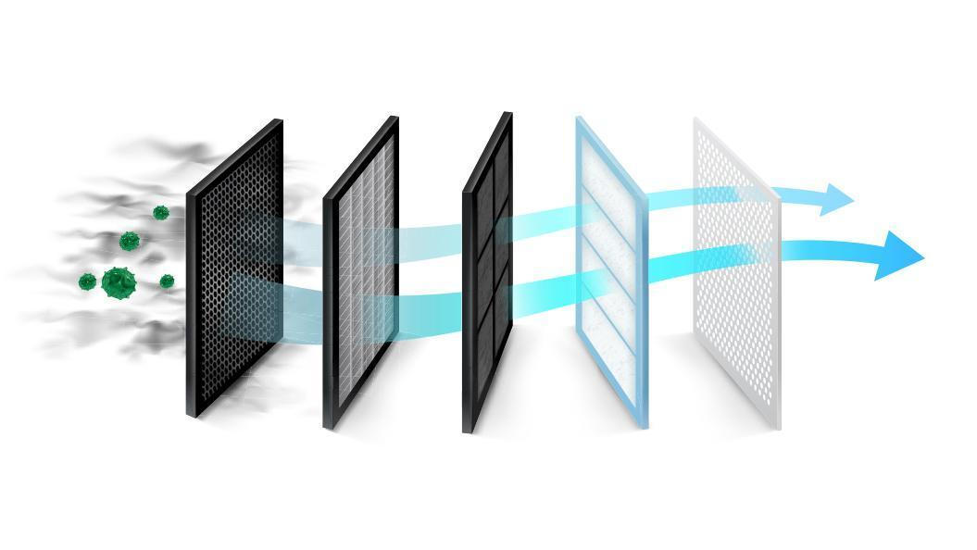

Figure 2. Installation of a new panel filter in a vehicle
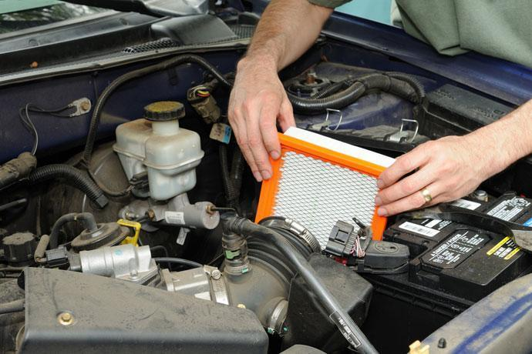

Figure 3. Filter market value in North America


Figure 4. Used and dirty panel air filter
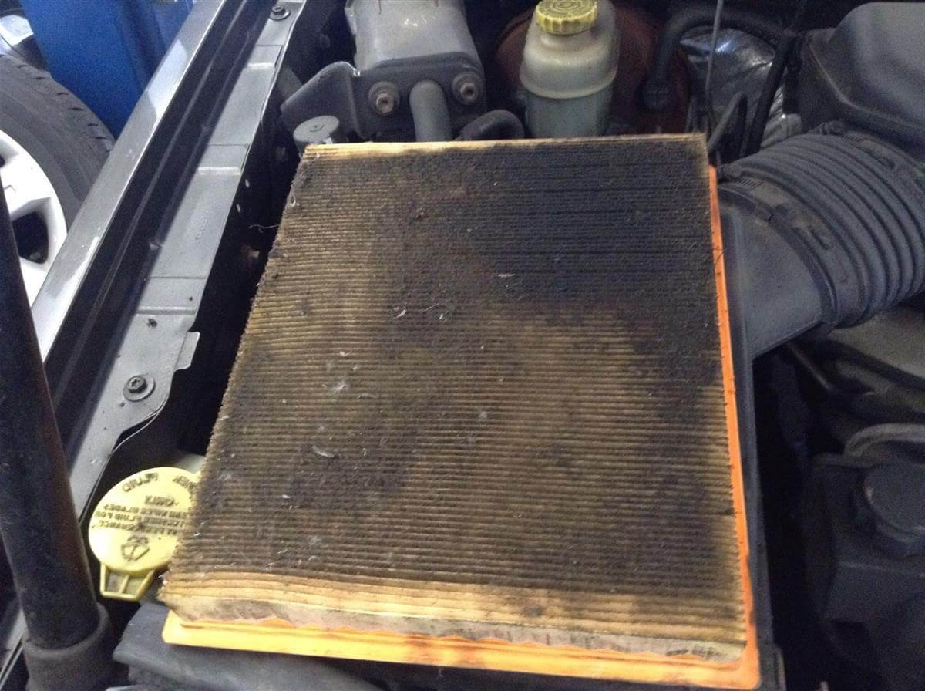

Figure 5. Filter types
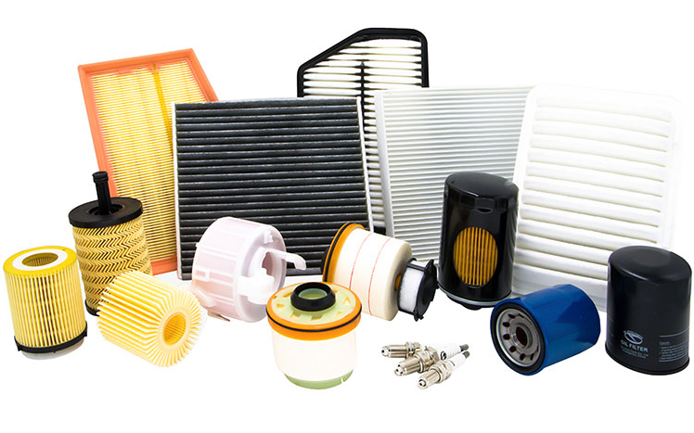

Figure 6. Example of a panel air filter
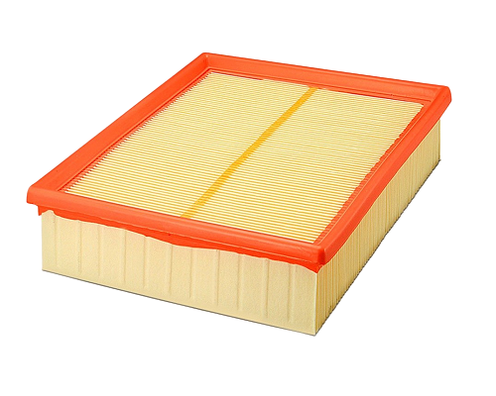

Figure 7. The section where the panel air filter must be installed in the vehicle
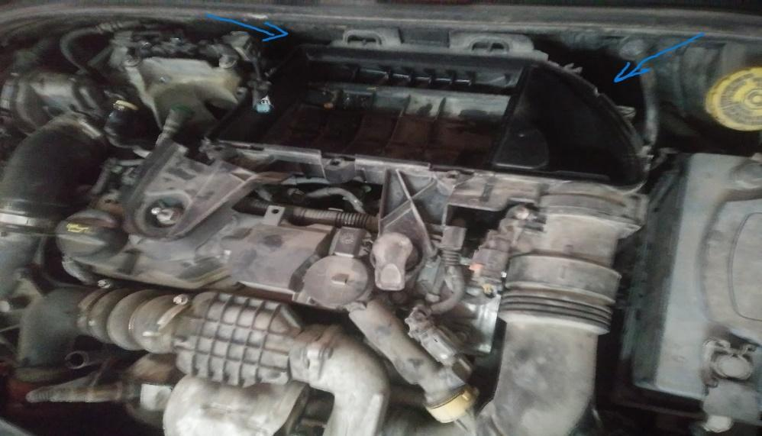

Figure 8. Expanded salmon-colored polyurethane
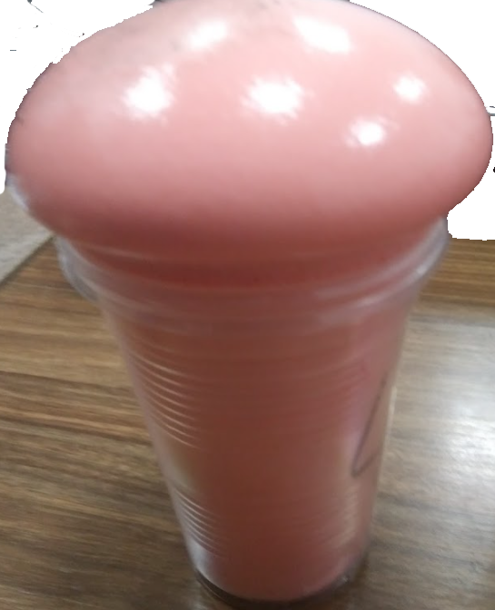

Figure 9. Pouring polyurethane into the mold with machine assistance
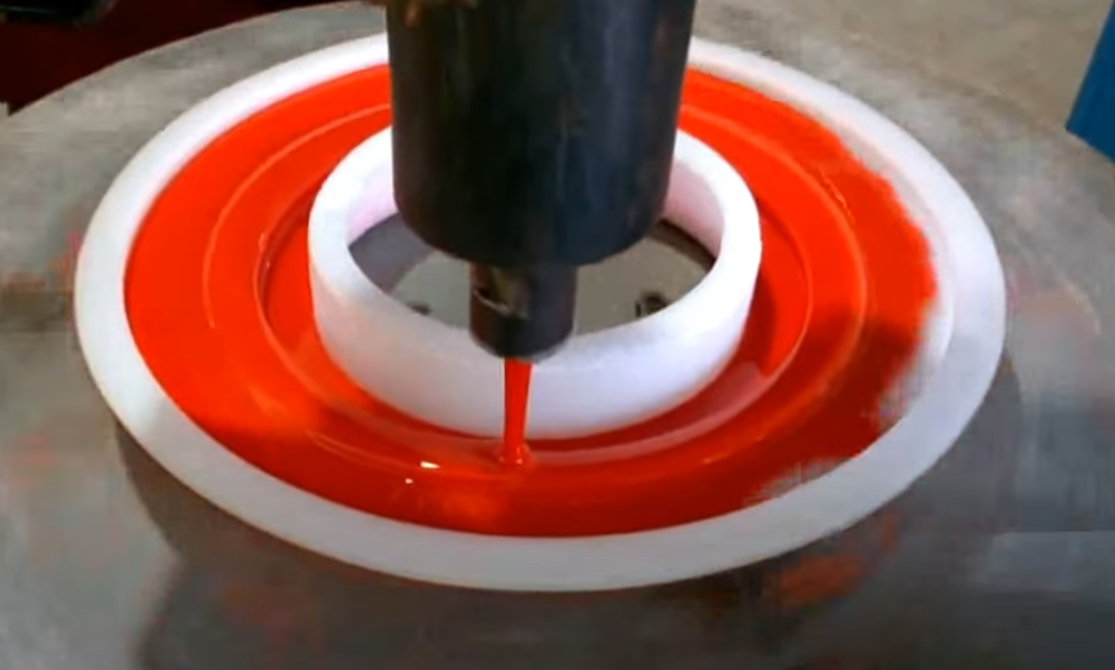

Figure 10. Four-strip hot-melt used in panel filters
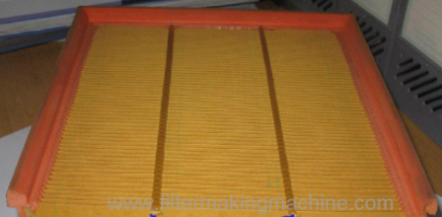

Figure 11. Panel air filter paper


Figure 12. The section where the polyurethane radial air filter must be installed in the vehicle
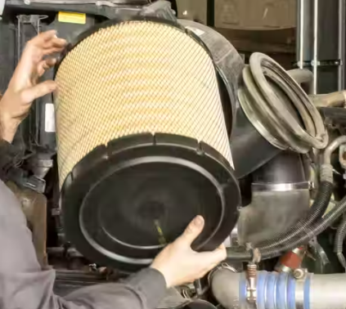

Figure 13. Radial air filter with sheet-metal cover
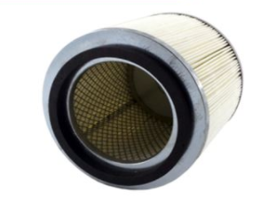

Figure 14. String-wrapping technology in radial filters
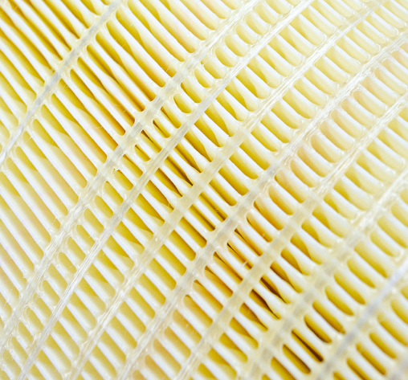

Figure 15. Flat perforated sheet-metal casing used in radial filters
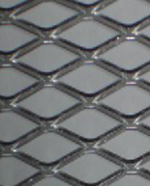

Figure 16. Polyurethane poured into a radial mold


Figure 17. Example of a felt inner filter
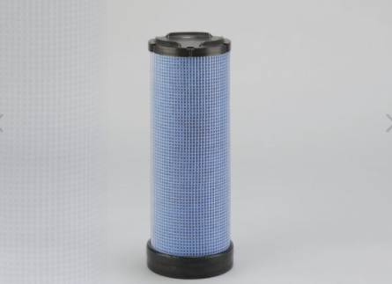

Figure 18. Structure of the filter paper used in a Powercore air filter
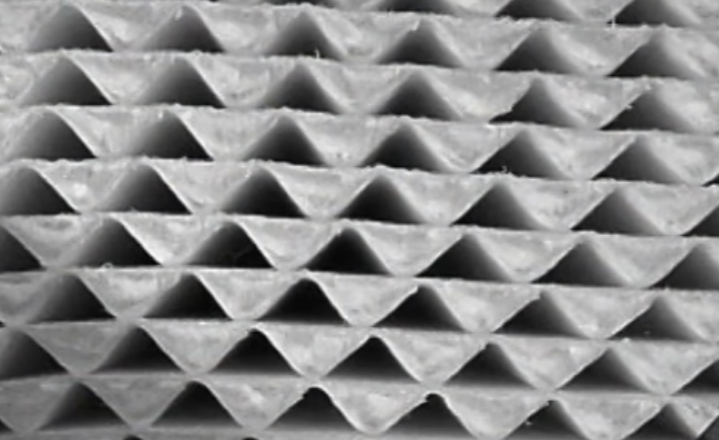

Figure 19. Powercore air filter together with its housing
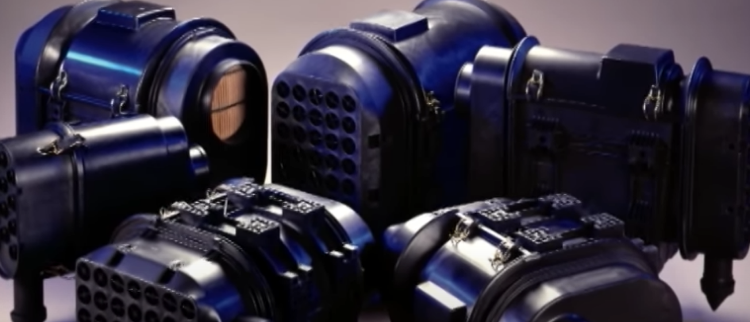

Figure 20. Powercore air filter as a kit
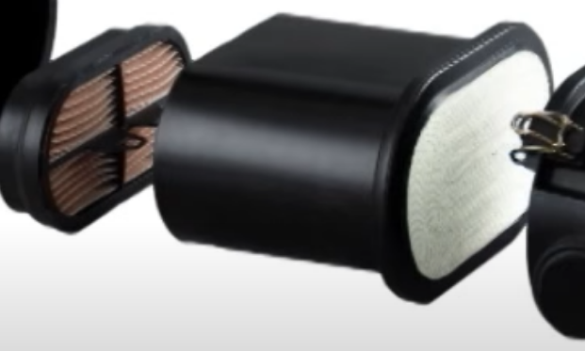

Figure 21. Powercore centering element
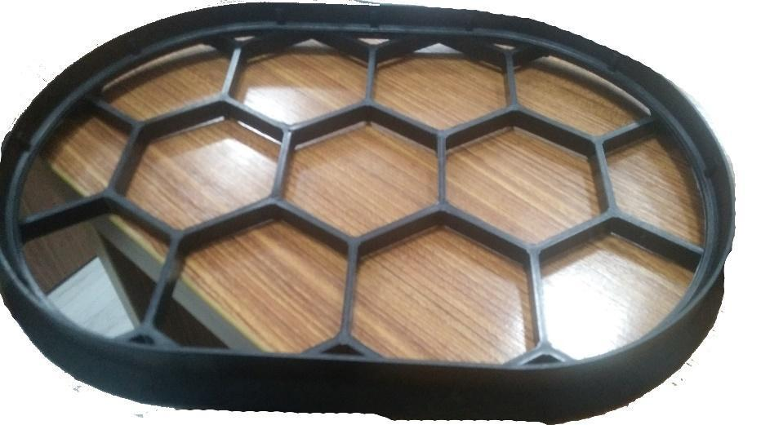

Figure 22. Pollen filter
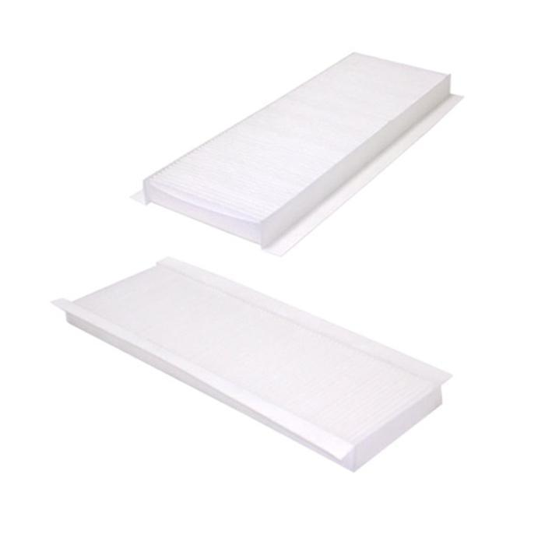

Figure 23. Dirty and clean pollen filters
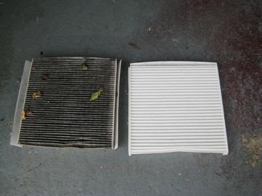

Figure 24. Layers of a carbon pollen filter
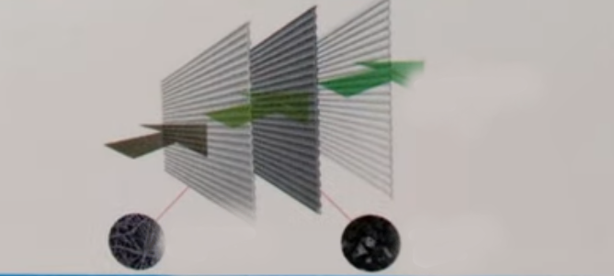

Figure 25. Carbon pollen filter
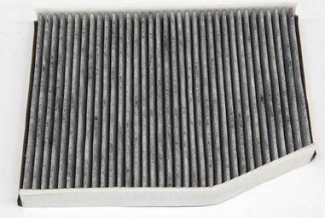

Figure 26. Pollen filter felt


Figure 27. Carbon pollen filter paper
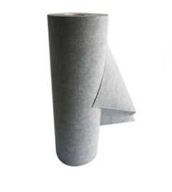

Figure 28. Oil filter replacement
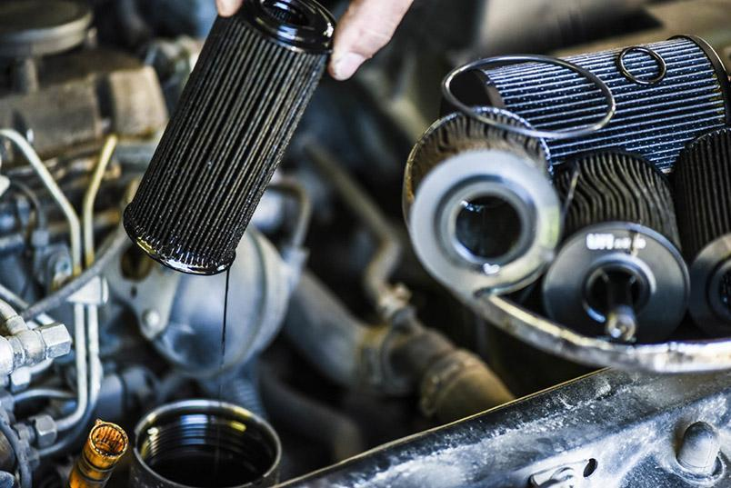

Figure 29. Types of oil filters
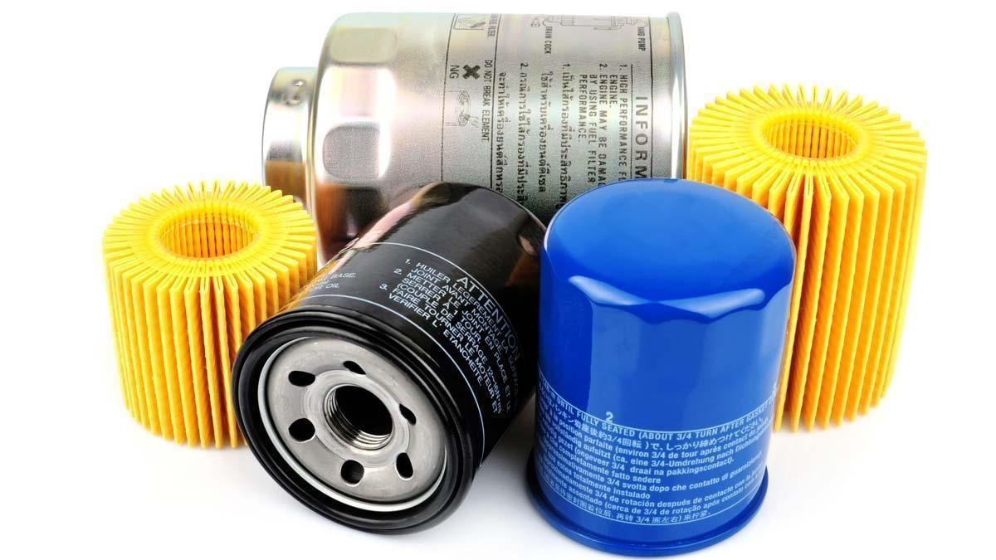

Figure 30. Schematic of a full-flow oil filter
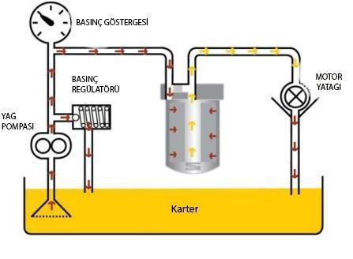

Figure 31. Ecological oil filter and gasket set
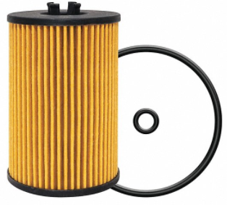

Figure 32. Spin-on type oil filter
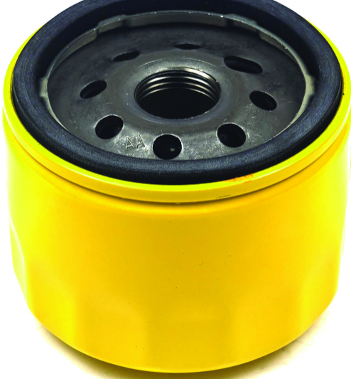

Figure 33. Oil flow in a spin-on type oil filter
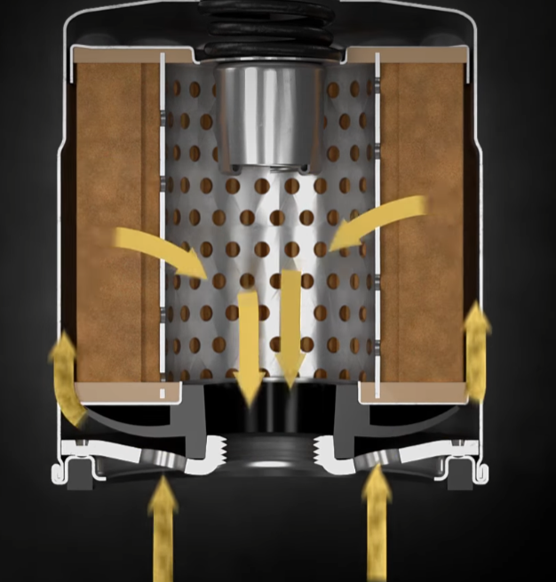

Figure 34. Spinner-type oil filter
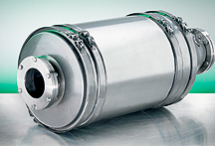

Figure 35. Magnetic oil filter
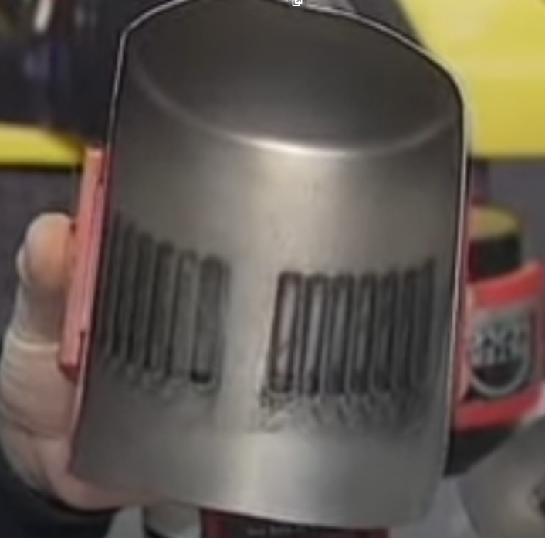

Figure 36. Examples of oil filter paper
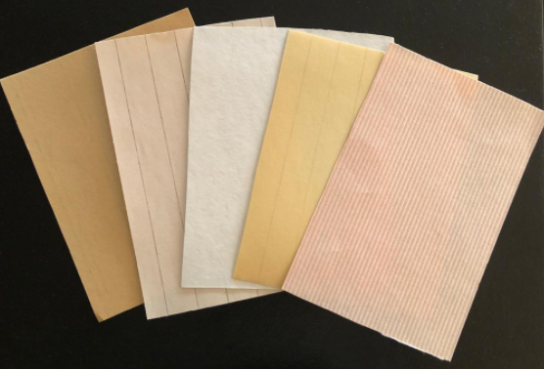

Figure 37. Fuel filters
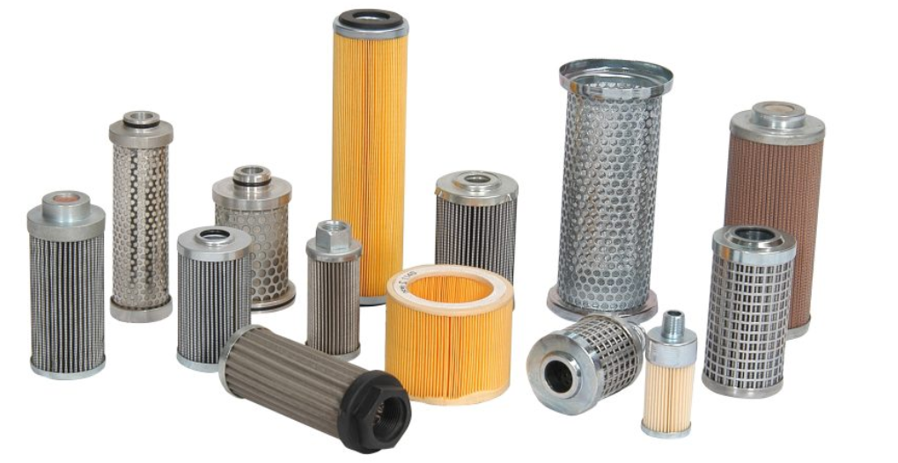

Figure 38. Diesel fuel filter
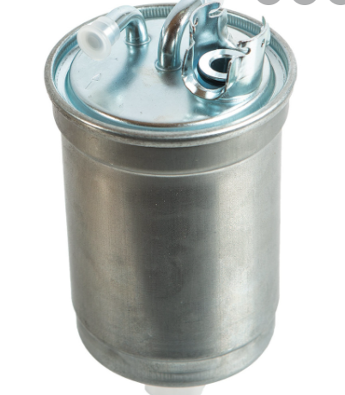

Figure 39. Gasoline fuel filter
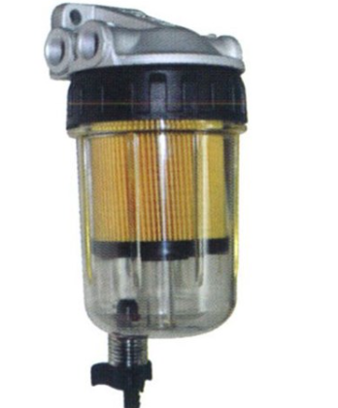

Figure 40. Example of a spin-on fuel filter
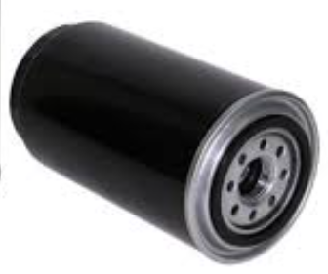

Figure 41. Examples of O-ring type element filter gaskets
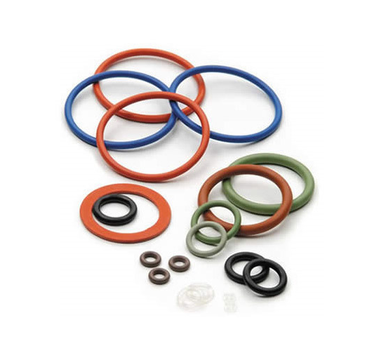

Figure 42. Example of green fuel filter paper


Figure 43. Mechanical caliper
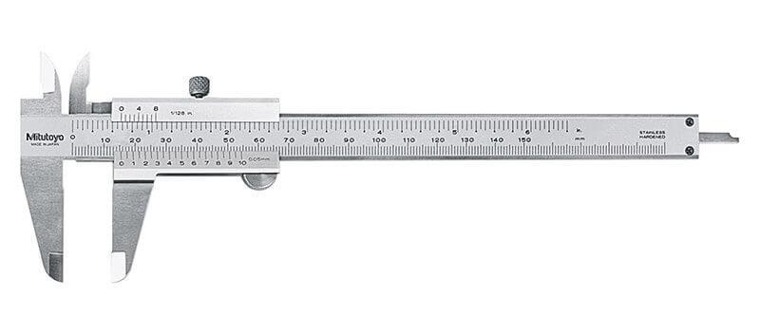

Figure 44. Precision scale
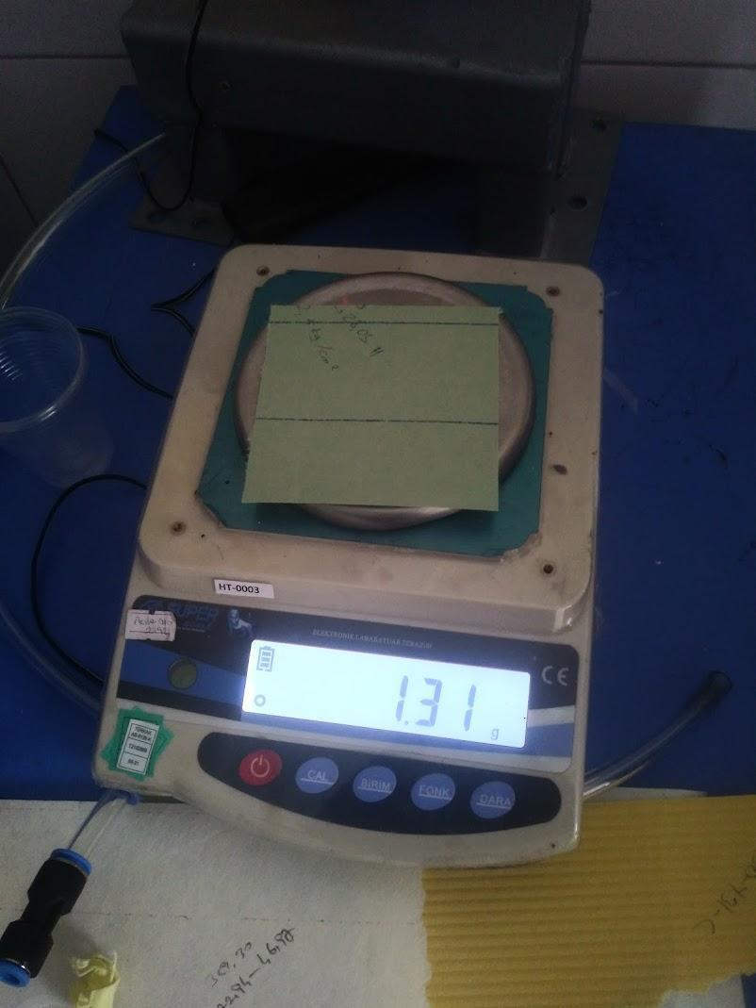

Figure 45. Radius gauge
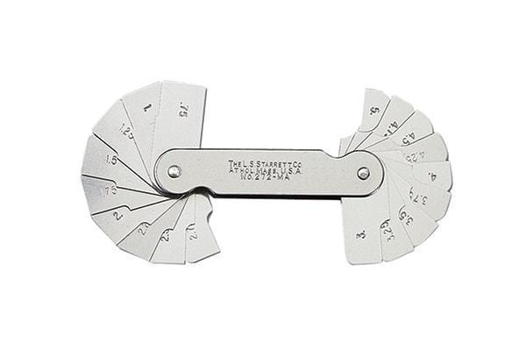

Figure 46. Shore meter
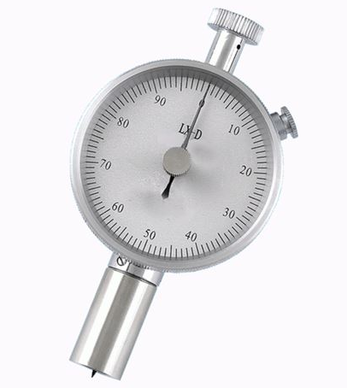

Figure 47. Micrometer
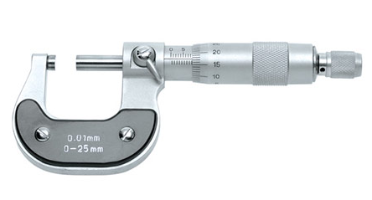

Figure 48. Filter paper thickness graph by product type
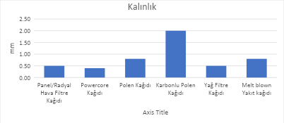

Figure 49. Placement of a filter paper sample into the test device
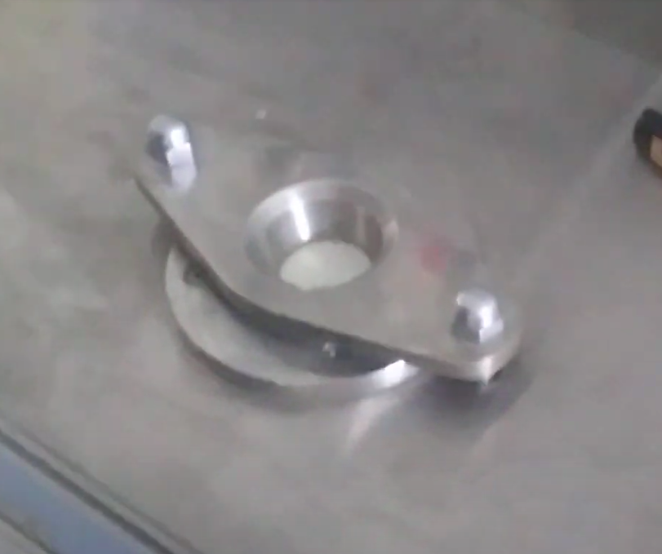

Figure 50. Filter paper test device display
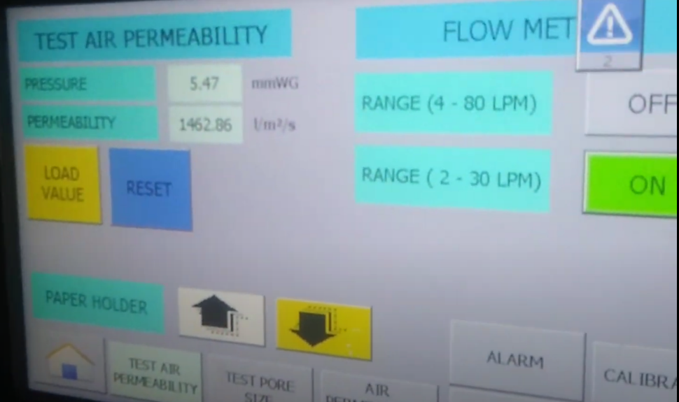

Figure 51. Comparison of air permeability of filter papers by product type
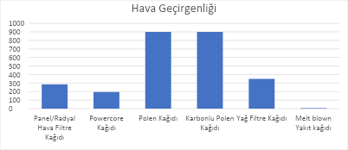

Figure 52. Burst pressure measurement
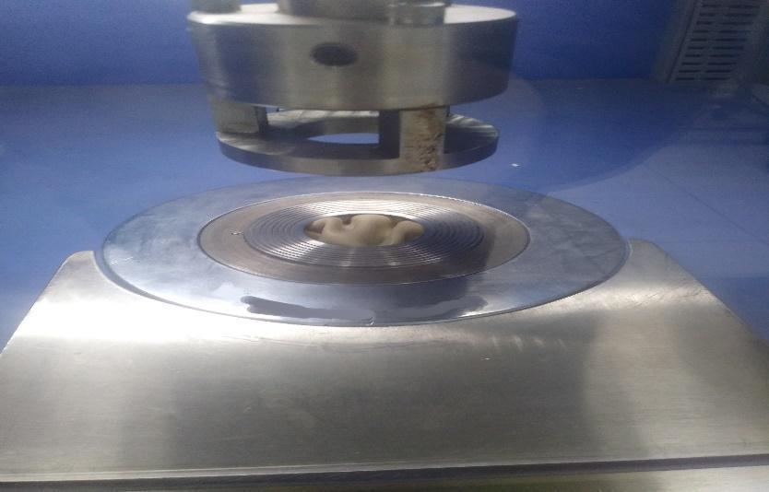

Figure 53. Cutting the paper for the chamber of the measuring device
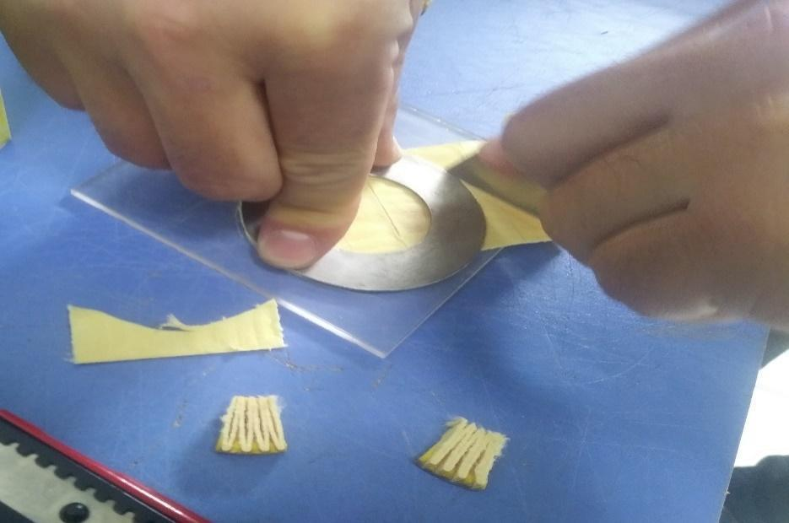

Figure 54. Air permeability display that should be reset because previous values remain
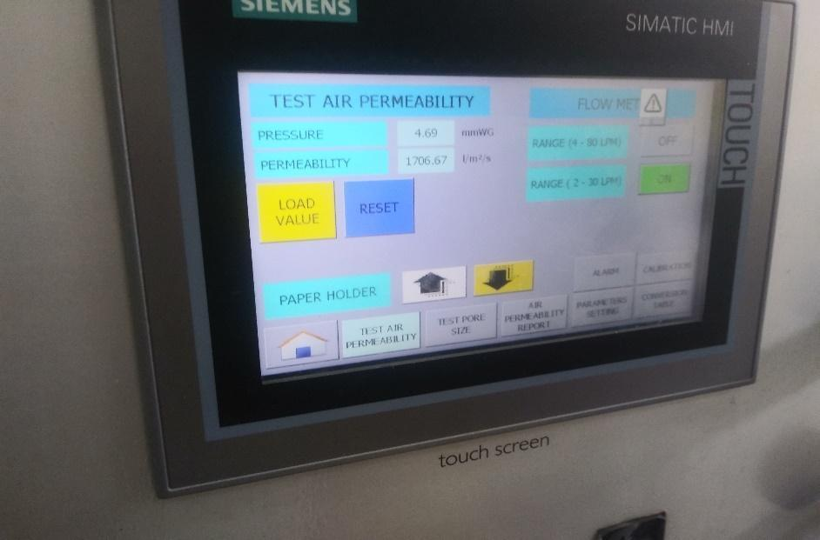

Figure 55. Adjustment of the air flow valve
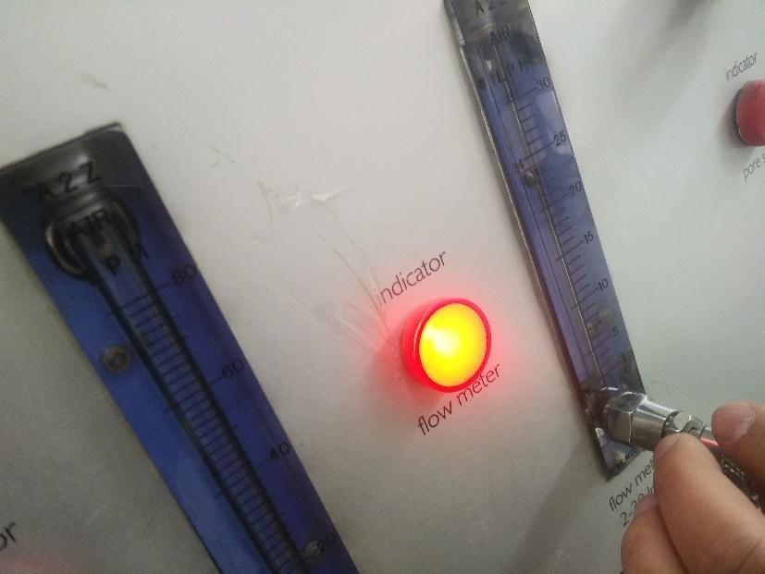

Figure 56. Reading the air permeability value from the display
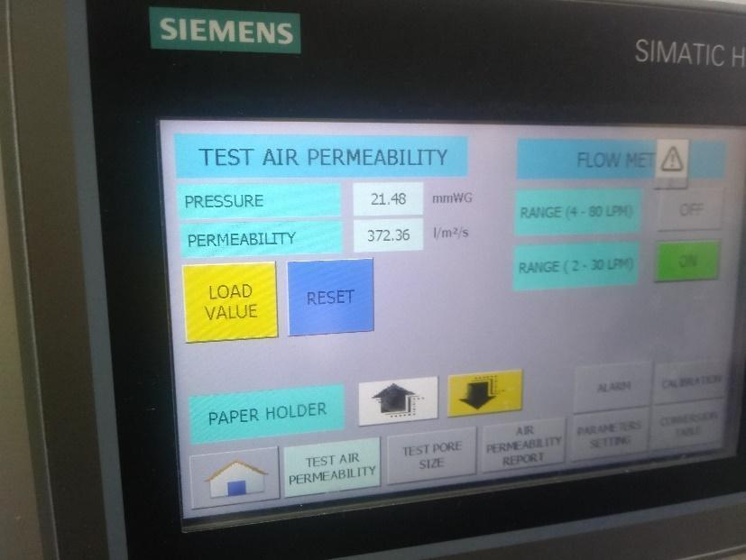

Figure 57. Pouring alcohol onto the paper for the pore permeability test
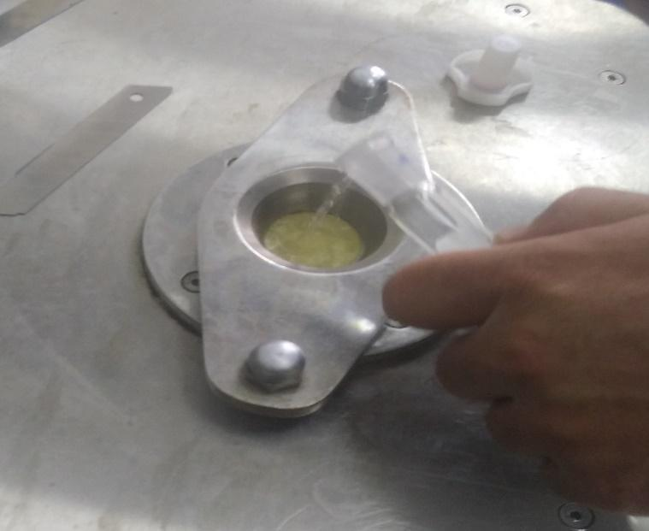

Figure 58. Opening the pressure regulator
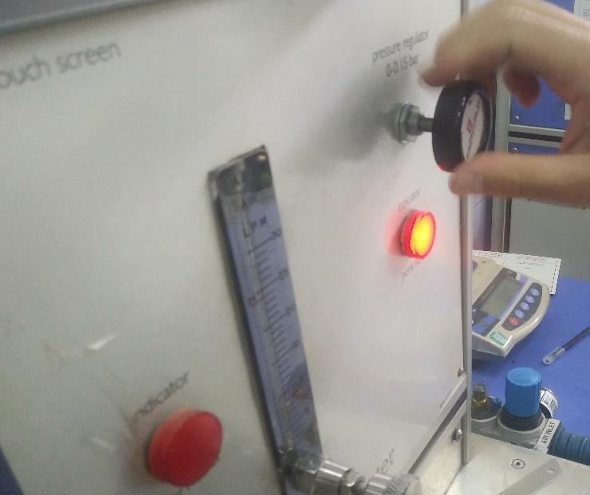

Figure 59. Measurement of maximum pore size
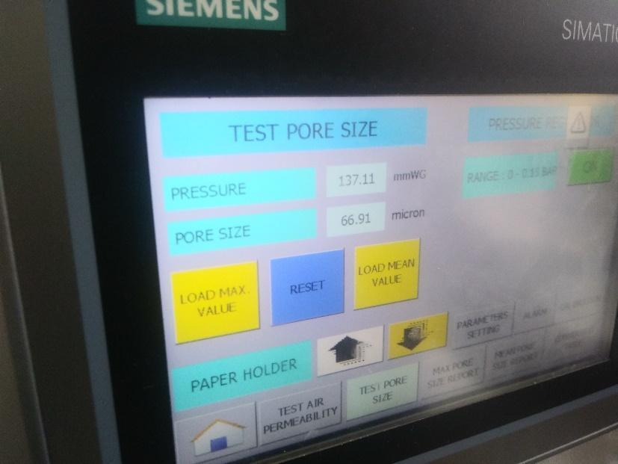

Figure 60. Average pore size
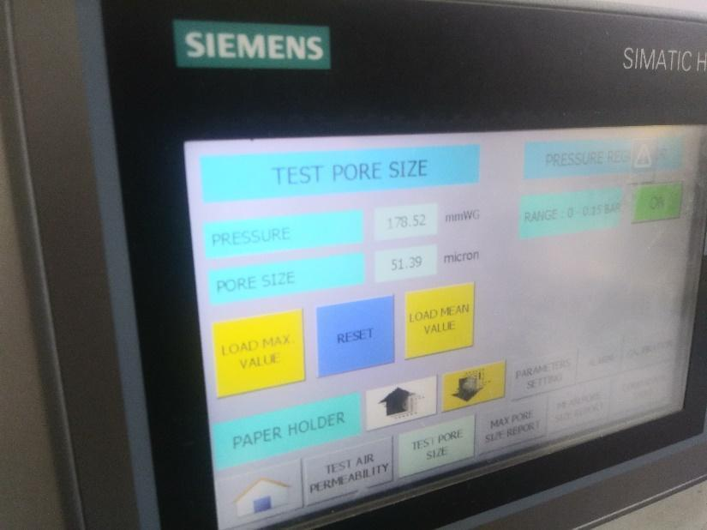

Figure 61. Oil filter paper placed in the burst pressure machine
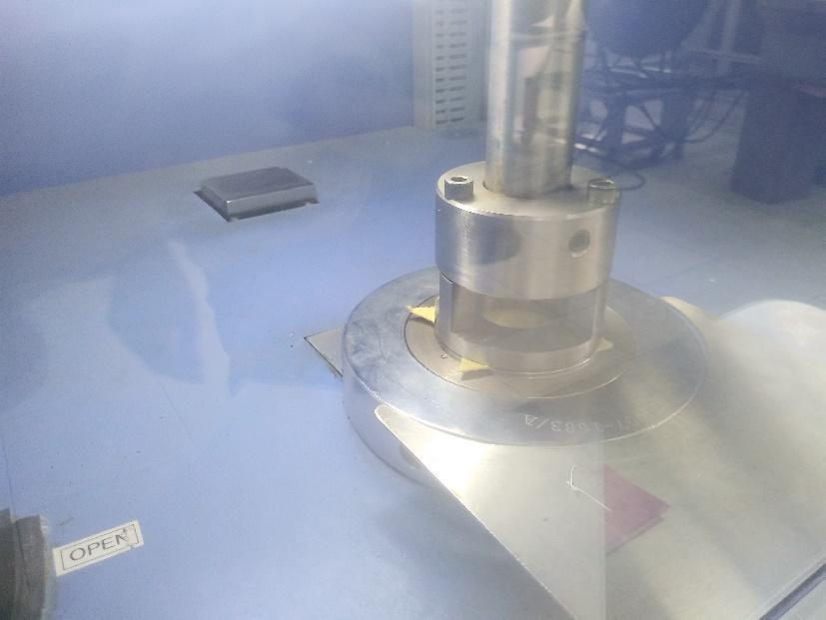

Figure 62. Burst pressure measurement display
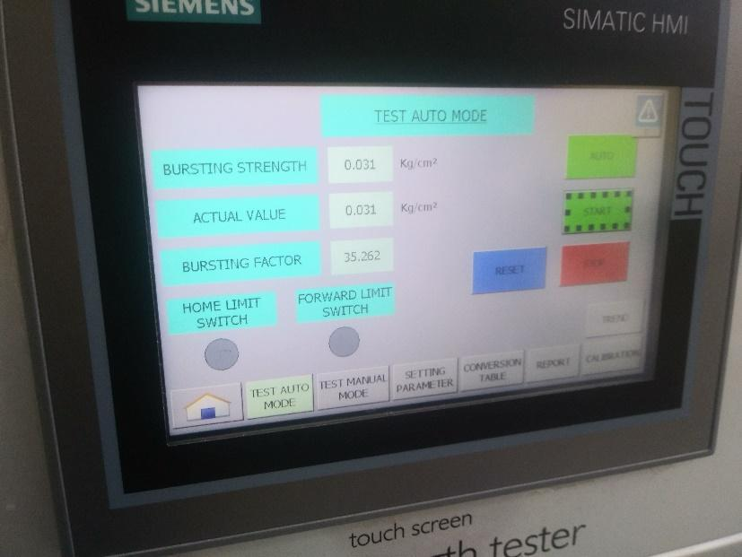

Figure 63. Reading the burst pressure from the screen
